YOUNG LEADERS SUMMIT 2019
Summary Report

Ecology North hosted the 6th Annual Young Leaders Summit on Climate Change from August 22nd, to August 28th, in the Inuvialuit and Gwich’in Regions. The group of eleven youth were selected from 28 applicants from across the Pan-Canadian North. Participants were asked to submit a short essay about why they would like to participate and have a letter of support from a respected person in their community. The participants were (in no particular order)
Emma Baldwin (Yukon)
Mariah MacDonald (NWT)
Ethan Eyakfwo (NWT)
Sheilany Bouchard (NWT)
Anonda Canadien (NWT)
Susan Machan (NWT)
Hannah Taneton (NWT)
Gillian Gear (Nunatsiavut)
Adonika Clark (Yukon)
Jessica sheppard (Nunatsivut)
Myha Martin (NWT)

Charlotte Morrit-Jacobs from APTN also joined the group as an embedded journalist (and engaged participant) for 4 days. Charlotte interviewed the youth, and filmed parts of the YLS adventures. Her show will be aired on APTN's current affairs show. APTN will also run a climate change episode on APTN's current affairs show "In Focus," climate change episode.
https://aptnnews.ca/climatechange/

The Young Leaders were facilitated by Ecology North staff Craig Scott and Rosalie Abbey.

The 6th annual Young Leaders Summit followed the format of the previous two, which were travelling tours with a heavy focus on experiential learning. Meeting influential people along the way, who share their experiences about climate change is in our opinion the best way to really absorb knowledge and have an experience that sinks in and grounds the participants. The group met in Inuvik, and travelled north up the new Inuvik to Tuk Highway, returned back to Inuvik, and down to the small community of Tsiigehtchic, before returning to Inuvik.
This report summarizes the trip and highlights some of the people we met and the experiences and knowledge we gained. All travel on the trip was offset by climate offsets from Planet Air.

We would like to gratefully acknowledge the support of our funders. GNWT’s Department of Environment and Natural Resources (ENR) and Municipal and Community Affairs (MACA), TIDES Foundation, McConnell Foundation (Climate Change Narratives), and NSERC’s Promoscience.

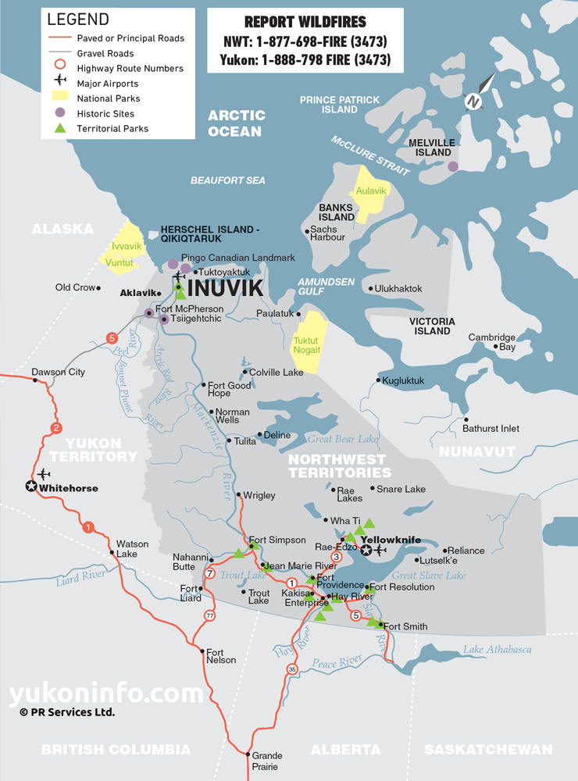

https://www.yukoninfo.com/northwest-territories-map/

August 22nd, 2019

Intro and Icebreaker:

We all met in the Inuvik square, and had a quick intro, icebreaker, and talked about what each of the youth wanted to learn during the week, and the experience and knowledge they had about climate change. There was a good mix of knowledge in the group, and everyone was very keen to learn. We completed a team charter as well that highlighted how we expected each other to be respectful and treat each other. Before heading across the street to Aurora Research Centre.

Aurora Research Centre (Western Arctic Research Centre) – Annika Trimble

Annika gave us a tour of ARI and we met a variety of researchers from around the globe who are studying in northern Canada. Some were focusing on Climate change, soil studies, methane, carbon flux as well as other environmental topics.

Rebecca Goodwin (Western University)
Gave us a presentation on Inuvialuit Living Project – which looked at archaeological history of the Inuvialuit region, and how climate change is impacting some of the archaeological sites (especially along the Arctic Coast).

Annika Gave us a presentation on the basics of Climate Science and career opportunities, and also ran through a few fun activities on climate science.

After lunch we drove up the New Inuvik to Tuk Highway, with the spectacular red colours of the tundra, the soft road (permafrost related) and the Husky Lakes.

Tuk TV

We arrived and went straight to the office of Tuk TV. We met Joroslav Malinowski, and some of his youth film crew. We had dinner, and snacks (thanks Tuk TV) and watched the movie “Happening to Us”. This is a great film, very inspiring, and filmed by youth, under supervision of Miro. After they put this together they showed to Catherine McKenna, who invited the crew to Chile for COP25. We had a good discussion after the movie.

The youth invited us to the Youth Centre, which they said was the best youth centre in NWT. It was a happening place, and full of youth. We camped just outside of town.

Check out this article in Chatelaine about Tuk TV.

August 23rd, 2019

Roy and Julia Cockney
We went for a walk around the point in the morning before meeting Roy and Julia Cockney (at the shelter by the point). Roy and Julia are elders who had loads of great information about the changes they’ve seen on the land. Some of their observations included:

- There are more storms now
- The ocean is higher
- The sandspit is disappearing
- August used to be nice weather, now its windier and cold
- There are more salmon now than there used to be
- The ice is much further out, it is less thick, (used to be 6 feet), now its thin and soft
- Spring its harder and less safe to go on the ice (April now isn’t safe even)
- Beaches are all disappearing, it’s hard to walk on the shores
- The Point where we are at is quickly eroding away. The Hamlet saw this happening years ago and started moving houses to Reindeer Point. Three houses have had to be moved this year
- There are different birds and animals, crows, eagles, beavers, bugs
- But Tuk is a good place there is lots of food – Mukluk, fish, berries, caribou
- The road is nice as you can go see people, but the price of food didn’t go down as promised

The youth had a bunch of good questions and we were very thankful to Roy and Julia for their knowledge and for sharing with us. They took us on a sod house tour, and craft shopping before we took them home and went to Grandma’s kitchen for dinner.

Drive Back to Inuvik:

On the drive home, we stopped along the tundra and used the permafrost probe (generously lent to us by ARI) to see the change in active layer near the disturbed road edge, versus further away from the road. The area near the road in the ditch the permafrost was much deeper, suggesting permafrost thaw, and a deeper active layer.

Jessica and Gillian from Nunatsiavut, joined us this evening, after having their flights delayed.

August 24th, 2019

Dez Loreen: Acting Mayor (Inuvialuit Communication Society)

Dez is the creative force behind ICS, but he is also the Deputy Mayor. Dez offered to give us his perspectives of Climate Change in his hometown. Although very humble about his lack of scientific knowledge of climate change Dez provided us with entertaining antecdotes about his youth, and how things have changed. Such as how the neighbourhood kids used to play on the utilidors running through town, and how they have changed, and the costs now associated with maintaining those (from Town perspective). How pilings used to be made of wood, and were 3 meters deep, now due to permafrost thaw they are metal and 8 meters deep. How Boot Lake has grown in size due to permafrost thaw. How you can see the wooden pilings of old buildings pushing up around town from frost jacking.

From the city perspective, the costs of adapting to climate change are severe. Adjusting the utilidor 3 or 4 times a year. Road repairs, water treatment plant, cost of new infrastructure and maintaining existing keeps rising. A house fell over a few years ago, and a bunch of other issues like the river changing, grolar bears, bears in the landfill etc.

Weronika Murray (Photographer) – Vanishing Land

Weronika is a photographer based in Inuvik who has been focusing her work on the vanishing coastline near Tuk. She showed us amazing images of coastal erosion, along the shoreline of the Beaufort. As she has been working with scientists, and the community she noted a few of the changes she’s seen and heard about:
- Tuk is sinking at 2 mm /year (glacial remnant), meanwhile water is rising, and erosion is taking away shoreline.
- Sediment and carbon are being released into the ocean
- The sediment and warmer water causes ocean acidification
- Ice Free season has changed from 95 to 110 days
- Warmer water means more storms, and more waves
- Plans to move 5 more houses this year
- Pelly Island is losing 30 to 40 metres a year

Farmers Market:

Went to the Farmers Market for lunch

Ray Solotki - Inuvik Community Garden
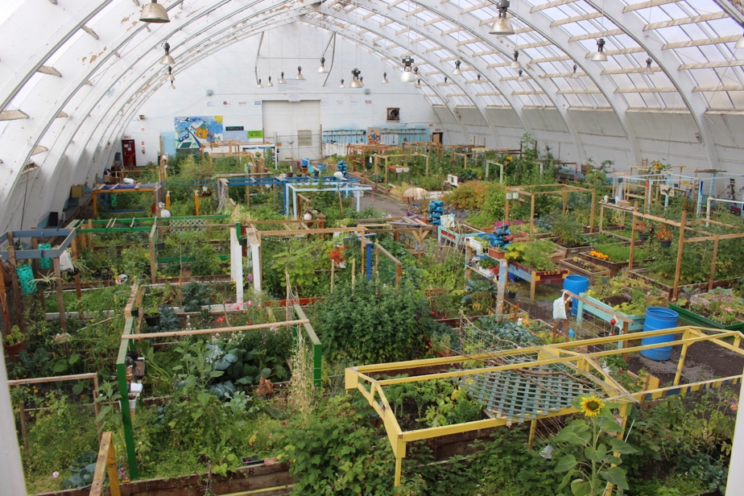
The Young Leaders were inspired by the energy and enthusiasm of Ray (the ED of the Inuvik Community Greenhouse). Ray gave a tour of the greenhouse, which was a former hockey arena for residential school Grollier Hall. The Greenhouse was converted by a group of volunteers into a greenhouse, it currently operates as a non-profit where community members can grow food in small plots (with equivalent food values of up to $1000). The greenhouse also grows bedding plants and flower baskets for Inuvik area and beyond. Ray also provides community support for growers in the Inuvialuit region, and through a community first approach has helped expand food production in each of these communities. The ICG also has a compost program in which it is hoping to expand throughout the City.

After the tour the Young Leaders offered to help with cleaning out the compost bins and helping set up for an event that evening. Ray was appreciative of the help from the Young Leaders and they were happy to get their hands dirty for a good cause.

Jordan Peterson: (Gwich’in Tribal Council) – Deputy Grand Chief

Jordon was very generous with his time, and has taken very seriously his role to support youth and climate action. He is working on climate change through a number of avenues. Through “Our Voices”, developing regional youth councils, and activities with universities such as “the next 40 conference”.

Jordan facilitated a workshop with youth to help figure out what their project might be. With lots of inspirational words and quotes: “Just try, don’t wait and see”
“go and knock on their door (politicians) everyday until they do something”
“our cultures are not stagnant”

Jordan helped the youth to think big picture: Together the group decided:

Top 5 priorities:
- Food Security
- Youth
- Knowledge
- Waste issues
- Inequality

How will you communicate:
- Plain Language
- With Actions
- In Partnership
- Belong to a movement

3 Barriers
- Cost
- People who say no to ideas
- Government

Jordan challenged the youth to report back to EN by March 15th on how they have accomplished their goals.

August 25th, 2019

Jordan Peterson (Next morning)

Jordan expanded on some of the work the Gwich’in are doing on mitigation and adaption.
- Partners in solar and wind (to offset diesel) – 1 MW of energy
- 30 homeowners in Inuvik net metered
- Working with University of Saskatchewan, and Fairbanks
- Setting research priorities for Gwich’in and looking for partnerships
- Making it mandatory that researchers come back and report
- Wellness Camp improvements
- Help reduce the costs of heating homes (costs $500 to $2000/month)
- Gwich’in Council international – consists of NWT Gwich’in, Old Crow, and Alaskan Gwich’in
- Sits on the Arctic Council
- Old Crow working on Independent power agreement. (subsequently they declared a climate emergency – showing true leadership)
- Skills Partnership Grant
- Proposal to help encourage and build community activators
- Energy toolkit
- ARENA – Arctic Remote Energy Network Academy
- on the Gwich’in Council international website

He had some advice if you want to get involved:
- Understand do you want to bring about climate change awareness or do something about climate change (they are different)
- Read through budget announcements
- Build relationships
- Learn to write proposals
- Think about “one question you’ve always wanted to ask your leaders
- If you want to challenge your leadership, don’t just complain, but provide solutions!

Finally, we watched “Paddle the North” a movie about 6 young men who paddle the Wind and Peel River and find themselves most moved by the people and land, then by the personal challenge that initially drew them north.

Sheena Adams: Arctic Energy Alliance

Arctic Energy Alliance is a non-profit who support communities and residents of NWT to reduce fossil fuel use, through energy efficiency, conservation and renewable energy. Sheena gave us a tour of Whitehorse solar installations, and energy projects. Inuvik has reached the 20% penetration rate, allowed by Northwest Territories Power Corp. With a 1.3MW wind turbine coming on site in Spring.

Northern Sustainable House, model home build to showcase energy efficiencies and renewables. East Three School Biomass, ChildCare Centre – Solar, NorthMart Solar, and a 30 homes initiative. ARI solar wall, we talked about passive solar heating, and the IRC Community Food Processing Centre. As well as the Smart Cities Challenge project in YK (that EN partnered with City), which piloted motion sensor streetlights.

Group photo ski club:

Abe Drennan: Teacher at East Three School, Supporter of Fridays for Future Inuvik Youth Climate Strikes

Abe gave us a rundown of what the Fridays for Future Strikes were about in Inuvik, March 15th they had their first strike. The youth were overwhelmed by the response from media. They started noon strikes but soon changed to 4pm to 5pm to get more attention. They didn’t realize what the impact would be. They had to learn how to be an activist and how to speak to the media.

He asked the youth what they wanted to accomplish and banning plastics was first thing. They were supported by the Mayor, asked the NorthMart Manager to reduce plastic, and NorthMart gave them 1500 reusable bags to give out. NorthMart did temporary measures but said if council asks to ban plastic we will. Learned a lot about activism.

Abe would like to compost in Inuvik. (Send Abe info on LoveNWTWater, Plastic Bag Ban, and Composting in schools)
Abe ran the group through a World Café exercise.

August 26th, 2019

Drive to Tsiigehtchic –
This 2-hour drive was resplendent in the autumn colours.

Stop at Renglen River to stretch legs, get a few photos.

Ferry Landing: (The Diamond Ring Stop) – Sheilany found a diamond ring on the ground

As the group waited for the ferry. We had a brief discussion about the impacts of climate change on ferries and ice roads. Impacts include:
- longer ferry seasons,
- shorter ice road seasons,
- greater costs for ice road construction and maintenance as the weather warms. Increased disruptions to ferry service due to lower river levels,
- more unpredictable shoulder seasons (between ferry and ice roads)
- Lower water levels, more sand bars disrupting ferry service (ie Fort Simpson)
- Lower water levels impacting barge resupply (ie Fort Good Hope), and
- Impacts to mine and community ice road seasons causing extra costs

James Andre:
James is the president of Arctic Borderlands – Which monitors and reports on changes in habitat, range and conditions of the Porcupine Caribou herd. Arctic Borderlands employs a harvester and youth in each of their 6 communities. This is an excellent example of community based research supporting a resource (the caribou) and collecting and disseminating changes on the land from people who are out on the land.

The Young Leaders had a delicious caribou stew and bannock lunch, and were joined by the head of the Designated Gwich’in Organization and elder John Norbert.

Tsiigehtchic Tour: James and John

James helped to organize our Tsiigehtchic adventures, and toured us around the community. John Norbert (an elder from Tsiigehtchic and member of the Renewable Resources Committee) joined us in a tour in which he showed us the Health Centre, which recently required a foundation overhaul after permafrost caused the oil tank to fall off its support and the building nearly split. The wooden piles were cut off and wooden pads and wedges were installed at great cost, and the Heath Centre was closed for most of a year (a victim of climate change).

The group were led to the Church where James talked about changes to the Arctic Red River, the giant slump 3 miles upriver and changes in break-up, which has decreased in size and violence considerably due to thinner ice and warmer winters.

Craig toured the group around the Church where in 2011 and 2012, Ecology North and EBA Engineering studied the potential of the stability of the hillside and threat to the church. The group looked at the fractures, talked about risk and potential solutions to permafrost slumping and creep. There are a range of potential solutions, some simple (like fencing the site off to keep snowmobiles and quads off the steep slopes, filling in the fractures, covering the slopes with erosion fabrics, managing vegetation, to expensive engineering solutions.

The Youth than looked at the steep hill below the cemetery and the dramatic slump just beyond, where the prehistoric Steppe Bison remains were found in 2007.

Wellness Centre: John Norbert and James Andre

We had a tour of the Wellness Centre and James led a Q and A session that focused on invasive species. Some of the invasive species noted were the insects which are changing quickly, spruce and pine beetles (which are in the Gwichin region and already impacting forests), cougars, deer, and fish species, in particular salmon. Alestine Andre (later that night) told us of her time at their fish camp and the 14 salmon of 3 species – (Chum, coho and pink salmon) that they caught.

We looked at the river flowing out of the water lake, which has been very dry for a couple of years. Everyone wanted to look for berries and James suggested by the Water Treatment Plant but we weren’t able to find many.

Agnes Andre: (Goose at the Fish Camp)

The Young Leaders were lucky enough to be hosted by Agnes Andre at her fish camp on the shores of the Mackenzie River. Unfortunately, the Arctic Red was flooding due to heavy rains recently not allowing Agnes to set her nets. She told us how the wet rainy weather this summer impacted all the harvesters and fishers, and without the sunny weather she wasn’t able to dry much fish.

But the community was very generous and we were gifted caribou, and fish from local harvesters to hold a feast. To the sounds of the local band the Hummingbirds on James’ truck cd player the Young Leaders, gleefully cut up a caribou leg and cooked up potatoes, ribs and fried caribou, along with local whitefish over the fire. Gillian and Jessica from Nunatsiavut were in particular very happy to have caribou, having been in region with a hunting moratorium for five years (where the George Caribou Herd decreased from 800,000 to 9,000 since 1990, related in part to climate change).

We were blessed with beautiful warm weather and joined by Alestine Andre and Itai Katz. Agnes brought out two geese which she taught the youth to pluck, singe over the fire and cut up. Everyone ate until they were full under the big white Tsiigehtchic sign on the hill.

Hannah and Ethan joined the community in a game of softball that evening.

August 27th, 2019

Breakfast and Research Discussion:
The next morning the youth cooked breakfast in the gym, and we had a guest presentation from researchers Natalie Anderson and Alicia Sendrowski. Who talked about their driftwood study, and how driftwood could tell the stories of the river’s ebbs and flows and floods and droughts. We discussed community needs around research and community based research. Why water levels in the Mackenzie are changing. Most of the water in the Mackenzie comes from the Peace and Athabasca rivers, which originate in northern BC and Alberta. Fluctuations in the Pacific impact snowpack in these mountains impacting water levels, while glacial melt also plays a role.

There was also a discussion around Bennet Dam and how it regulates seasonal flooding by holding back water for winter base flow, and how Site C will further impact the river system. As the open water summer season lengthens with climate change and evaporation, and sublimation (snow turning directly to airborne moisture), glaciers shrink and snowpack becomes more erratic, there will be greater impacts on the river, flooding, icepack, scouring and sedimentation from permafrost thaw and slumps.

We talked about the need for community researchers and opportunities for youth to take leadership positions and join the Renewable Resource Council’s and participate in decisions around resources and the land.

ARI – Field Researchers Km 252

We had a rapid departure from Tsiigehtchic in order to catch the ferry which was swinging around from the Fort McPherson side. Following a bumpy ride back to Inuvik we met with Edwin Castillo and two other Aurora Research Institute environmental technicians, who showed us Chris Burn’s permafrost sampling site at Km 252. Edwin shared with us how to sample the site, looking at active layers and talked about some of the research support they do, and the opportunities in for youth to become researchers.

Amy Amos – Gwich’in Renewable Resources Board

We met with Amy Amos and her staff (Cheryl and Leanne), on the grass by the boat launch. Amy is the ED of the Gwich’in Renewable Resources Board (GRRB). She gave us a rundown of what the GRRB does, and the opportunities for science that supports the communities and management plans. Talking about job opportunities and the importance of community based science, seems like a theme on this day.

Rising Youth – Garret Cochrane

Following that we met with Garett Cochrane from Rising Youth, who facilitated a workshop with the youth in the public square. Rising Youth provides funding to youth to complete an impactful community service or project. A workshop helped develop ideas and eventual proposals to Rising Youth. Some of the ideas included: community greenhouse, proposal writing workshop for community, shoreline clean-up, tool library, language revitalization, youth (on the land) cabin, camping program, enviro radio program, and sports league.

Climate Change Communication:

That evening after supper we had one final session on communicating climate change, facilitated by Craig. A few key points:

The Do’s
- Think about your audience and how much they know about Climate Change
- Climate action isn’t just about climate but it will also improve air pollution, health outcomes, reduce future conflict, create jobs and a just transition.
- Talk about climate change using local examples
- Tie climate change to health, water, youth, wildlife
- Present a positive hopeful argument
- Make it personal, bring it back to what people care about (health, kids, community?)
- Tell stories and make it about people (ideally those they know or yourself)
- There is no one solution (it’s not about carbon tax) but millions of individual and collective actions that are needed
- We all need to work together
- To be effective we need to create a movement where people can feel they are heard and belong
- This is and needs to be youth led
- There is a sense of urgency, there are technologies changing the world, but we can’t wait for a tech solution, we need regulations, market based solutions, innovation, and global consensus
- Be realistic and hopeful, but acknowledge that we all need to make sacrifices, but if we do it together it will be manageable. The costs if we don’t will be more severe.
- As Greta Thunberg says, we already have the answers, we just all need to agree to do them

The Don’ts
- Don’t argue with climate deniers, focus on those who aren’t decided (pro or con climate change action) – “leave them with a terse response about the future generation being the judge, or perhaps the science is wrong”
- Don’t argue, but acknowledge differences of opinion and that science seems to favour an argument for action
- Don’t lead with economics
- Don’t focus on carbon pricing (people mostly have mindset around this already)
- Don’t focus on Doom and gloom -turns people off

August 28th – Departure Day

The Young Leaders packed up camp for the final day and caught their flights back to their home communities. Thanks, everyone for coming with an open-mind, bringing enthusiasm, ideas, questions and a desire to make change.

Appendix A:

A few Select Climate Change Resources:

The Energy Mix http://theenergymix.com/

Mitchell Beer puts together a weekly newsletter with excellent content on energy and climate change. Canadian Content. If you are only going to sign up to one newsletter this is what I recommend.

The Independent Barents Observer:

An independent Scandinavian publication that highlights Arctic Issues in Scandinavia and Russia in particular.

Ecology North

EN has a weekly newsletter with information on what’s going on in NWT and Yellowknife.

Yukon Conservation Society

YCS has a monthly newsletter highlighting events and activities in the environmental movement in Yukon. Great source of info on the Peel watershed.

Pembina Perspectives:

Pembina Institute has a weekly newsletter that highlights energy issues and sustainability with a Western Canada focus.

Podcasts:

Costing the earth – a BBC show challenging assumptions about climate change
https://www.bbc.co.uk/programmes/b006r4wn

Mothers of Inventions – about women climate warriors

2050: Degrees of Change – CBC podcasts about different trends into the future.

MIT All Ears – what’s the science behind climate change
(http://news.mit.edu/2015/podcast-science-behind-climate-change-0422)

NASA has a great website with all kinds of climate change links, videos, a kids portal and of course images and remote sensing shots of earth.

